CCNPv7.1 SWITCH

Lab 7-2 Configure Campus Network Devices to support Simple Network Management Protocol (SNMPv3)
Topology
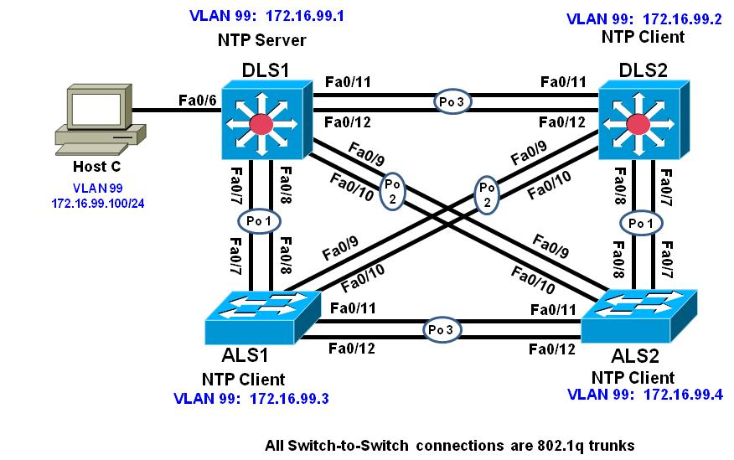
Objective
- Configure an SNMP View
- Configure SNMP version 2c
- Configure SNMP version 3
- Verify SNMP operation

Background
The Simple Network Management Protocol (SNMP) is an application layer protocol that facilitates the exchange of management information between an agent and a management server. SNMP enables network administrators to monitor and manage network performance, find and solve network problems, and plan for network growth. SNMP management workstations can ask (get) for the value of a specific object identifier (OID) from the management information base (MIB) maintained by SNMP agents. The Manager can also configure (set) specific variable values in an OID. Additionally, the agent can send notifications (traps or informs) when an event occurs or threshold is reached (simply put, an inform is a trap that must be acknowledged by the manager). Like any powerful tool, SNMP can be dangerous if not used properly, and securing the protocol and its uses are critical.

There are three SNMP versions. SNMPv3 is considered the most secure because it offers authentication and encryption, where SNMP versions 1 and 2 offer neither. SNMP access can also be limited using an access control list.

In this lab you will configure SNMP v3 on the distribution layer switches and SNMP v2c on the access layer switches. The network should still be configured and operating based on the configurations that you applied in Lab 7-1 Synchronizing NTP in the campus network. All SNMP communications will be carried on the Management VLAN (VLAN 99), and agent access will be restricted to the IP address of the Network management Server (HOST C).

Note: This lab uses Cisco Catalyst 3560 and 2960 switches running Cisco IOS 15.0(2) IP Services and LAN Base images, respectively. The 3560 and 2960 switches are configured with the SDM templates “dual-ipv4-and-ipv6 routing” and “lanbase-routing”, respectively. Depending on the switch model and Cisco IOS Software version, the commands available and output produced might vary from what is shown in this lab. Catalyst 3650 switches (running any Cisco IOS XE release) and Catalyst 2960-Plus switches (running any supported Cisco IOS image) can be used in place of the Catalyst 3560 switches and the Catalyst 2960 switches.

Required Resources
- 2 switches (Cisco 2960 with the Cisco IOS Release 15.0(2)SE6 C2960-LANBASEK9-M image or comparable)
- 2 switches (Cisco 3560 with the Cisco IOS Release 15.0(2)SE6 C3560-ipservicesK9-M image or comparable)
- Ethernet and console cables
- 1 PC (Windows Host with a Static IP) with Network Monitoring software (the free version of ManageEngine MIB Browser is used in this lab
- Prepare for the Lab
This lab uses the existing configurations from Lab 7-1 Synchronizing NTP in the Campus Network. The NTP functionality and security is not critical to perform this lab. However, you will need L2 trunking configured.
  - Configure host access for Host C
Configure DLS1 interface F0/6 for access to VLAN 99 and configure Host C with the IP address 172.16.99.100/24 with a default gateway of 172.16.99.1. Verify Host C can ping all four switch management interfaces.
- Configure general SNMP parameters
In this part you will configure general SNMP parameters that will be used by all four switches.
  - Configure general SNMP information
Configure general values to identify the device, it's location, and a point of contact. Configure this with appropriate values on all four switches:

DLS1(config)# snmp-server location DLS1 Rack 1
DLS1(config)# snmp-server contact Student
DLS1(config)# snmp-server chassis-id Cisco 3560v2 SN FTX2222222
  - Configure access-lists for SNMP.
Configure an access list on each switch. This ACL will be used to specify exactly where SNMP get and set messages should be coming from. In this lab, the 172.16.99.0/24 network is the management network. Configure this ACL on all four switches:

DLS1(config)# ip access-list standard NMS-SERVERS
DLS1(config-std-nacl)# permit 172.16.99.0 0.0.0.255
DLS1(config-std-nacl)# exit
  - Configure an SNMP view.
Access to the MIB is open access by default, and any authorized user can read or change the value of any OID in the MIB. Besides the ACL, you should also configure SNMP VIEWs. A view specifically allows or disallows access to certain parts of the MIB, which can provide both security and help control CPU utilization by limiting large SNMP polls.
The MIB is large and there are many different branches and variables, so how the views are configured really depends on how the NMS is implemented versus other SNMP access to the system. Views should be created and configured to contain those variables required by the different entities that might use SNMP to access your devices.
The output below is a basic view configuration that follows Cisco's guidance for OID access located at http://www.cisco.com/en/US/docs/ios-xml/ios/snmp/configuration/12-4t/nm-snmp-cfg-snmp-support.html. The commands specify the "root" of the MIB tree and then further specifies sub-branches that are excluded. Configure this view on all four switches.
DLS1(config)#snmp-server view NMS-LIMIT iso included
DLS1(config)#snmp-server view NMS-LIMIT 1.3.6.1.2.1.4.21 excluded
DLS1(config)#snmp-server view NMS-LIMIT 1.3.6.1.2.1.4.22 excluded
DLS1(config)#snmp-server view NMS-LIMIT 1.3.6.1.2.1.4.35 excluded
DLS1(config)#snmp-server view NMS-LIMIT 1.3.6.1.2.1.3 excluded
DLS1(config)#snmp-server view NMS-LIMIT 1.3.6.1.6.3.15 excluded
DLS1(config)#snmp-server view NMS-LIMIT 1.3.6.1.6.3.16 excluded
DLS1(config)#snmp-server view NMS-LIMIT 1.3.6.1.6.3.18 excluded
The OID values in the above configuration correspond to the following:
Note: iso in the text below refers to the root of the MIB tree
1.3.6.1.2.1.4.21 is (iso-1).(org-3).(dod-6).(internet-1).(mgmt-2).(mib2-1).(ip-4).(ipRouteTable-21).
1.3.6.1.2.1.4.21 is (iso-1).(org-3).(dod-6).(internet-1).(mgmt-2).(mib2-1).(ip-4).(ipNetToMediaTable-22).
1.3.6.1.2.1.4.21 is (iso-1).(org-3).(dod-6).(internet-1).(mgmt-2).(mib2-1).(ip-4).(ipNetToPhysicalTable-35).
1.3.6.1.2.1.3 is (iso-1).(org-3).(dod-6).(internet-1).(mgmt-2).(mib2-1).(atTable-3)
1.3.6.1.6.3.15 is (iso-1).(org-3).(dod-6).(internet-1).(snmpv2-6).(snmpModules-3).(snmpUsmMIB-15)
1.3.6.1.6.3.16 is (iso-1).(org-3).(dod-6).(internet-1).(snmpv2-6).(snmpModules-3).(snmpVacMMIB-16)
1.3.6.1.6.3.18 is (iso-1).(org-3).(dod-6).(internet-1).(snmpv2-6).(snmpModules-3).(snmpCommunityMIB-18)
The NMS-LIMIT view above will protect some of the SNMP credentials from accidental exposure (nsmpUsmMIB, snmpVacmMIB, snmpCommunityMIB) and deny access to the Routing Table (ipRouteTable), the ARP table (atTable), and the deprecated ipNetToMediaTable and ipNetToPhysicalTable OIDs.
- Configure DLS1 and DLS2 for SNMPv3
  - Configure SNMP groups.
SNMP groups are a construct that allows for users and views to be associated with one another.
Included as a part of the group configuration for SNMPv3 is the security model (no auth, auth, or priv), optional associated read, write, and inform views, and optional access-list controlling source addresses in the group.
In the output below, a group called ccnp-switch3 is created to use SNMPv3, the security features implemented by the group, the read view of NMS-LIMIT and is restricted by the ACL NMS-SERVERS. Configure this on both DLS1 and DLS2. An example from DLS1:

DLS1(config)# snmp-server group ccnp-switch3 v3 priv read NMS-LIMIT access NMS-SERVERS

  - Configure SNMP users.
Configure users on DLS1 and DLS2. They will use an SNMPv3 user who is a part of the group ccnp-switch3. They will authenticate using SHA with password cisco123, and will encrypt using AES 128 with a password of cisco123. Configure this on both DLS1 and DLS2. An example from DLS1:

DLS1(config)# snmp-server user student ccnp-switch3 v3 auth sha cisco123 priv aes 128 cisco123

Note: This command will not show in the running configuration after it is entered.
After configuring the user, you should see this SYSLOG message:
Configuring snmpv3 USM user, persisting snmpEngineBoots. Please Wait...
  - Configure SNMP trap receiver
Configure the NMS server traps will be sent to. As a part of this command, specific traps or sets of traps to send can be specified. If no traps are specified, this receiver will be forwarded all traps that are enabled. This particular configuration needs to be coordinated with the network management system and network monitoring requirements for the organization.
Configure 172.16.99.100 as a trap receiver for DLS1 and DLS2 For simplicity, do not configure any trap limits. Configure this on both DLS1 and DLS2. An example from DLS1:

DLS1(config)# snmp-server host 172.16.99.100 traps version 3 priv student
  - Configure Interface Index Persistence.
Network monitoring systems record throughput and other interface statistics using SNMP polling. Each interface is referenced by its unique index number, which is dynamically assigned by the IOS upon boot. The index of each interface can be determined with the command show snmp mib ifmib ifindex. The dynamic assignment aspect of this can be problematic for documentation. Therefore, it is a good idea to instruct the system to keep a persistent list of interfaces rather than a dynamic one. The use of this command creates a file stored in NVRAM. Configure this on both DLS1 and DLS2. An example from DLS1:

DLS1(config)# snmp-server ifindex persist

  - Enable SNMP Trap Sending
This final command actually enables the forwarding of traps to the configured trap receivers. As a part of this command, traps can be limited (as they can be in the snmp-server host command). Once again this will need to be coordinated with the network management system and network monitoring requirements for the organization. Configure this on both DLS1 and DLS2. An example from DLS1:

DLS1(config)# snmp-server enable traps

  - Verify SNMP configuration.
To very quickly verify that traps are being sent, issue the command debug snmp packets and then enter configuration mode. You should see debug output indicating a packet was sent:
DLS1# debug snmp packets
SNMP packet debugging is on
DLS1#
DLS1# conf t
Enter configuration commands, one per line. End with CNTL/Z.
DLS1(config)#
Jul 30 18:27:05.274: SNMP: Queuing packet to 172.16.99.100
Jul 30 18:27:05.274: SNMP: V2 Trap, reqid 1, errstat 0, erridx 0
sysUpTime.0 = 37646
snmpTrapOID.0 = ciscoConfigManMIB.2.0.1
ccmHistoryEventEntry.3.7 = 1
ccmHistoryEventEntry.4.7 = 2
ccmHistoryEventEntry.5.7 = 3
DLS1(config)# end
DLS1# undebug all

Use the show snmp command to view configuration information for SNMP:
DLS1# show snmp
Chassis: Cisco 3560v2 SN FTX2222222
Contact: Student
Location: DLS1 Rack 1
0 SNMP packets input
0 Bad SNMP version errors
0 Unknown community name
0 Illegal operation for community name supplied
0 Encoding errors
0 Number of requested variables
0 Number of altered variables
0 Get-request PDUs
0 Get-next PDUs
0 Set-request PDUs
0 Input queue packet drops (Maximum queue size 1000)
1 SNMP packets output
0 Too big errors (Maximum packet size 1500)
0 No such name errors
0 Bad values errors
0 General errors
0 Response PDUs
1 Trap PDUs
SNMP global trap: enabled

SNMP logging: enabled
Logging to 172.16.99.100.162, 0/10, 1 sent, 0 dropped.
SNMP agent enabled
DLS1#
Use the show snmp view command:
DLS1# show snmp view
cac_view pimMIB - included read-only active
cac_view msdpMIB - included read-only active
cac_view ip - included read-only active
cac_view ospf - included read-only active
cac_view bgp - included read-only active
cac_view dot1dBridge - included read-only active
cac_view ipMRouteStdMIB - included read-only active
cac_view igmpStdMIB - included read-only active
cac_view ipForward - included read-only active
cac_view ipTrafficStats - included read-only active
cac_view ospfTrap - included read-only active
cac_view sysUpTime.0 - included read-only active
cac_view ciscoPingMIB - included read-only active
cac_view ciscoStpExtensionsMIB - included read-only active
cac_view ciscoIpSecFlowMonitorMIB - included read-only active
cac_view ciscoPimMIB - included read-only active
cac_view ciscoMgmt.187 - included read-only active
cac_view ciscoEigrpMIB - included read-only active
cac_view ciscoCefMIB - included read-only active
cac_view ciscoIpMRouteMIB - included read-only active
cac_view ciscoIPsecMIB - included read-only active
cac_view cospf - included read-only active
cac_view ciscoExperiment.101 - included read-only active
cac_view ciscoIetfIsisMIB - included read-only active
cac_view ifIndex - included read-only active
cac_view ifDescr - included read-only active
cac_view ifType - included read-only active
cac_view ifAdminStatus - included read-only active
cac_view ifOperStatus - included read-only active
cac_view snmpTraps.3 - included read-only active
cac_view snmpTraps.4 - included read-only active
cac_view snmpTrapOID.0 - included read-only active
cac_view snmpMIB.1.4.3.0 - included read-only active
cac_view lifEntry.20 - included read-only active
cac_view cciDescriptionEntry.1 - included read-only active
NMS-LIMIT iso - included nonvolatile active
NMS-LIMIT at - excluded nonvolatile active
NMS-LIMIT snmpUsmMIB - excluded nonvolatile active
NMS-LIMIT snmpVacmMIB - excluded nonvolatile active
NMS-LIMIT snmpCommunityMIB - excluded nonvolatile active
NMS-LIMIT ip.21 - excluded nonvolatile active
NMS-LIMIT ip.22 - excluded nonvolatile active
NMS-LIMIT ip.35 - excluded nonvolatile active
v1default iso - included permanent active
v1default internet - included permanent active
v1default snmpUsmMIB - excluded permanent active
v1default snmpVacmMIB - excluded permanent active
v1default snmpCommunityMIB - excluded permanent active
v1default ciscoMgmt.252 - excluded permanent active
*tv.FFFFFFFF.FFFFFFFF.FFFFFFFF.FFFFFFFF.FFFFFFFF.FFFFFFFF.FFFFFFFF.FFFFFFFF.FFFFFFFF.FFFFFFFF.FFFFFFFF.FFFFFFFF.FFFFFFFF.FFFFFFFF.FFFFFFFF0F iso - included volatile active
*tv.FFFFFFFF.FFFFFFFF.FFFFFFFF.FFFFFFFF.FFFFFFFF.FFFFFFFF.FFFFFFFF.FFFFFFFF.FFFFFFFF.FFFFFFFF.FFFFFFFF.FFFFFFFF.FFFFFFFF.FFFFFFFF.FFFFFFFF0F iso.2.840.10036 - included volatile active

Verify SNMP groups.

DLS1# show snmp group
groupname: ccnp-switch3 security model:v3 priv
contextname: <no context specified> storage-type: nonvolatile
readview : NMS-LIMIT writeview: <no writeview specified>
notifyview: *tv.FFFFFFFF.FFFFFFFF.FFFFFFFF.F
row status: active access-list: NMS-SERVERS

DLS1#

Verify SNMPv3 users:

DLS1#show snmp user
User name: student
Engine ID: 800000090300E840406F7283
storage-type: nonvolatile active
Authentication Protocol: SHA
Privacy Protocol: AES128
Group-name: ccnp-switch3

  - Configure MIBBrowser software
This lab uses the free tool "MIBBrowser" from ManageEngine for verification. Other tools that will listen for traps at are acceptable substitutes as well.

On the MIBBrowser file menu, select Edit and Settings. Select the SNMP version 3 radio button, select “Save V3 Settings to file and then click ADD.

. 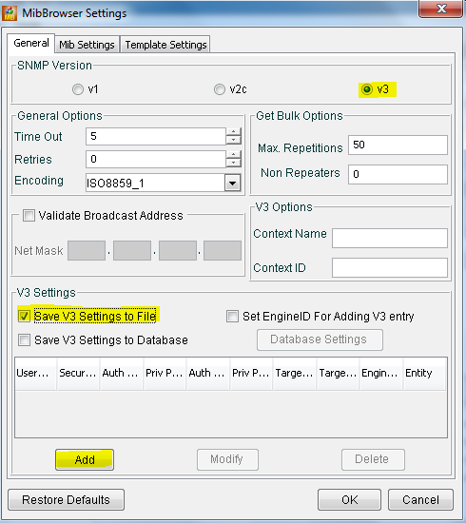

On the SnmpParameterPanel, fill in the values for the SNMPv3 user:

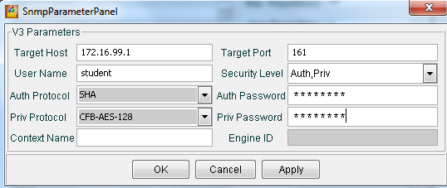

- Target Host: IP Address of DLS1 (172.16.99.1)
- User Name: student
- Security Level: Auth,Priv
- Auth Protocol: SHA
- Auth Password: cisco123
- Priv Protocol: CFB-AES-128
- Priv Password: cisco123
Once the values are entered, then, click ok. Click Add again and add DLS2 (172.16.99.2) with the same values.

Once values are added for both devices, select DLS1’s entry and click OK.

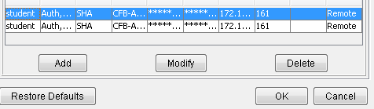

  - Verify SNMP TRAP Operation
Run MibBrowser. Select View and then Trap Viewer from the File Menu. The TrapViewer window will open. Uncheck the "Authenticate v1/v2c traps (Community). Click into the Community field and change 'public' to 'ccnp-switch3' and click the add button.
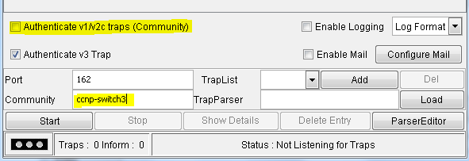
Finally, click Start. TrapViewer is now listening for traps.
Go to the command prompt at DLS1 and DLS2 and enter configuration mode. You should see at least two SNMPv3 traps collected in the TrapViewer. This validates that traps are being sent to the designated host.
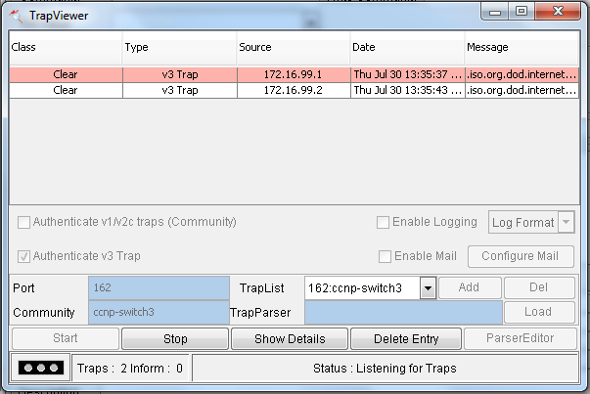

  - Verify SNMP GET Operation

Move the TrapViewer window out of the way (do not close it) and click on the main MibBrowser window. Under the "Loaded MibModules" category, expand SNMPv2-MIB, internet, mgmt, mib-2, and system and then select sysLocation. Right click and select GET. You should see the system location information you configured previously appear in the center window.

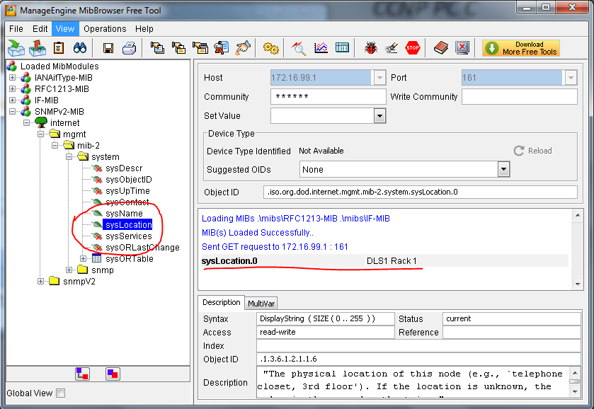

Click on Edit, then Settings. Select the second SNMPv3 entry and click OK, then repeat the above steps to verify SNMPv3 is working with DLS2.

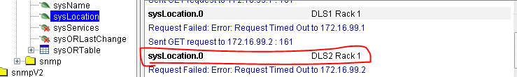

- Configure ALS1 and ALS2 for SNMPv2c
  - Configure SNMP Community String.
SNMPv2c using a community-string based authentication. Access can be limited further by using an access list. Create a read-only community named ccnp-switch2 that is limited by the NMS-SERVERS ACL and restricted to the view NMS-VIEW that was created earlier. Configure this on both ALS1 and ALS2. An example from ALS1:

ALS1(config)# snmp-server community ccnp-switch2 view NMS-LIMIT ro NMS-SERVERS
  - Configure SNMP trap receiver
Configure the NMS server traps will be sent to. As a part of this command, specific traps or sets of traps to send can be specified. If no traps are specified, this receiver will be forwarded all traps that are enabled. This particular configuration needs to be coordinated with the network management system and network monitoring requirements for the organization.
Configure 172.16.99.100 as a trap receiver using SNMPv2c and the community ccnp-switch2. Configure this on both ALS1 and ALS2. An example from ALS1:

ALS1(config)# snmp-server host 172.16.99.100 version 2c ccnp-switch2

  - Configure Interface Index Persistence.
Network monitoring systems record throughput and other interface statistics using SNMP polling. Each interface is referenced by its unique index number, which is dynamically assigned by the IOS upon boot. The index of each interface can be determined with the command show snmp mib ifmib ifindex. The dynamic assignment aspect of this can be problematic for documentation. Therefore, it is a good idea to instruct the system to keep a persistent list of interfaces, rather than a dynamic one. The use of this command creates a file stored in NVRAM. Configure this on both ALS1 and ALS2. An example from ALS1:
ALS1(config)# snmp-server ifindex persist
  - Enable SNMP Trap Sending
This final command actually enables the forwarding of traps to the configured trap receivers. As a part of this command, traps can be limited (as they can be in the snmp-server host command). Once again this will need to be coordinated with the network management system and network monitoring requirements for the organization. Configure this on both ALS1 and ALS2. An example from ALS1:
ALS1(config)# snmp-server enable traps
  - Verify SNMP configuration.
To very quickly verify that traps are being sent, issue the command debug snmp packets and then enter configuration mode. You should see debug output indicating a packet was sent:
ALS1# debug snmp packets
SNMP packet debugging is on
ALS1#
ALS1# conf t
Enter configuration commands, one per line. End with CNTL/Z.
ALS1(config)#
Jul 30 18:57:17.770: SNMP: Queuing packet to 172.16.99.100
Jul 30 18:57:17.770: SNMP: V2 Trap, reqid 1, errstat 0, erridx 0
sysUpTime.0 = 878054
snmpTrapOID.0 = ciscoConfigManMIB.2.0.1
ccmHistoryEventEntry.3.5 = 1
ccmHistoryEventEntry.4.5 = 2
ccmHistoryEventEntry.5.5 = 3
ALS1(config)# end
ALS1# undebug all
At this point, look at the TrapViewer window and you should see a v2c trap was received.
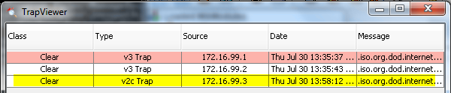

Use the show snmp command to view configuration information for SNMP:
ALS1# show snmp
Chassis: Cisco 2960 SN FTX4444444
Contact: Student
Location: ALS1 Rack 1
0 SNMP packets input
0 Bad SNMP version errors
0 Unknown community name
0 Illegal operation for community name supplied
0 Encoding errors
0 Number of requested variables
0 Number of altered variables
0 Get-request PDUs
0 Get-next PDUs
0 Set-request PDUs
0 Input queue packet drops (Maximum queue size 1000)
1 SNMP packets output
0 Too big errors (Maximum packet size 1500)
0 No such name errors
0 Bad values errors
0 General errors
0 Response PDUs
1 Trap PDUs
SNMP global trap: enabled

SNMP logging: enabled
Logging to 172.16.99.100.162, 0/10, 1 sent, 0 dropped.
SNMP agent enabled
ALS1#

Use the show snmp community command (community will be repeated for each VLAN, noted by the @[vlan #]):
ALS1# show snmp community

Community name: ccnp-switch2
Community Index: ccnp-switch2
Community SecurityName: ccnp-switch2
storage-type: nonvolatile active access-list: NMS-SERVERS

Community name: ccnp-switch2@1
Community Index: ccnp-switch2@1
Community SecurityName: ccnp-switch2
storage-type: read-only active access-list: NMS-SERVERS

Community name: ccnp-switch2@1002
Community Index: ccnp-switch2@1002
Community SecurityName: ccnp-switch2
storage-type: read-only active access-list: NMS-SERVERS

Community name: ccnp-switch2@1003
Community Index: ccnp-switch2@1003
Community SecurityName: ccnp-switch2
storage-type: read-only active access-list: NMS-SERVERS

Community name: ccnp-switch2@1004
Community Index: ccnp-switch2@1004
Community SecurityName: ccnp-switch2
storage-type: read-only active access-list: NMS-SERVERS

Community name: ccnp-switch2@1005
Community Index: ccnp-switch2@1005
Community SecurityName: ccnp-switch2
storage-type: read-only active access-list: NMS-SERVERS

Community name: ccnp-switch2@99
Community Index: ccnp-switch2@99
Community SecurityName: ccnp-switch2
storage-type: read-only active access-list: NMS-SERVERS

ALS1#

  - Verify SNMP TRAP Operation
MibBrowser's TrapViewer should still be open and listening for traps, and you should have already seen a trap from ALS1. Go into configuration mode on ALS2 and verify a trap is received.

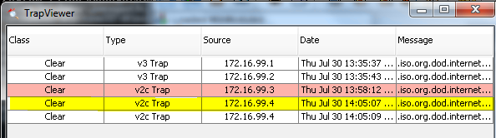

  - Verify SNMP GET Operation

Next to verify GET operations in SNMPv2c are working, go back to the Settings screen (edit>settings) and change the radio button selection from v3 to v2 and click OK.

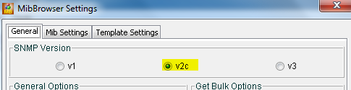

Once you click OK you will be returned to the main screen. Here the host settings fields will be available for editing . In the Host field, type 172.16.99.3 (ALS1), and in the Community field, type ccnp-switch2. Under the "Loaded MibModules" category, expand SNMPv2-MIB, internet, mgmt, mib-2, and system and then select sysLocation. Right click and select GET. You should see the system location information you configured previously appear in the center window. Repeat this process for ALS2 (172.16.99.4) to verify SNMPvc is configured correctly on this device.

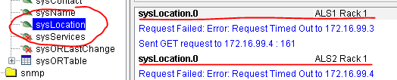
  - End of Lab
Do not save your configurations. The equipment will be reset for the next lab.

